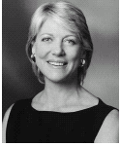 | Lynn Forester de Rothschild  Founder and Chief Executive  E.L. Rothschild LLC
 | Since June 2002, Lady de Rothschild has been the Chief Executive of E.L. Rothschild LLC, a private investment company, with investments in media, information technology, agriculture, real estate and luxury goods. Lady de Rothschild has been a director of The Estee Lauder Companies since December 2000, The Economist Newspaper Limited (member of the Audit Committee) since October 2002 and Weather Central LLP since January 2011. From 2004-2007, she was also Co-Chair of FieldFresh Pvt. Ltd, a 50-50 joint venture with Bharti Enterprises, established to develop the Indian agricultural sector in India. From 1989 to 2002, she was President and Chief Executive Officer of FirstMark Holdings, Inc., which owned and managed various telecommunications companies worldwide. She was Executive Vice President for Development at Metromedia Telecommunications, Inc. from 1984 to 1989. She began her career in 1980 as an associate at the law firm of Simpson, Thacher and Bartlett LLP in New York City, where she practiced corporate law. She is also a trustee of the American Fund for the Tate, FAI (Fondo per L’Ambiente Italiano), the Outward Bound Trust, the ERANDA Foundation (de Rothschild family foundation), the Alfred Herrhausen Society of International Dialogue of Deutsche Bank, an Advisor to the Deutsche Bank Microfinance Consortium ad the International Advisory Board of Columbia University School of Law. Lady de Rothschild is a member of the United Nations Advisory Committee on Inclusive Financial Services, the Council on Foreign Relations (USA), Chatham House (UK), the International Advisory Council of Asia House (UK), the International Institute of Strategic Studies (UK), and the Foreign Policy Association (USA). She served as a member of the National Information Infrastructure Advisory Committee and the Secretary of Energy Advisory Board under President Clinton. She graduated from Pomona College in Claremont, California (1976) and received her Juris Doctor in law from Columbia University in New York City (1980).
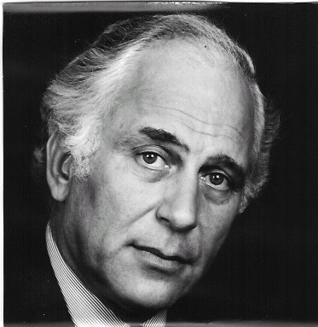 | Sir Evelyn de Rothschild  Sir Evelyn is currently Chairman of E.L. Rothschild Ltd, a private investment company with interests worldwide. Sir Evelyn is also a Director of IMG Worldwide Inc. He is Chairman of the ERANDA Foundation, a family foundation he founded in 1967 to support charities working in the fields of medical research, health and welfare, education and the arts.  In addition, Sir Evelyn currently serves as a Governor of the London School of Economics and Political Science, a Member of the Council of the Royal Academy of Dramatic Art, Chairman of Cambridge Business School Appeal, and Honorary Life President of Norwood and Ravenswood Children's Charity. He was Chairman and CEO of NM Rothschild and Sons Ltd, the international investment bank, from 1976 until 2003. From 1972 until 1989, Sir Evelyn also served as Chairman of The Economist Group, was formerly Chairman of St Mary’s Hospital Medical School in London, Member of the Council of the Shakespeare Globe Trust and President of the Evelina Children’s Hospital Appeal.  He was knighted by Queen Elizabeth II in 1989 for services to banking and finance. He is married to Lynn Forester and has three children and two step-children.

